Week 5 portfolio
Zongwei Liu 3013031
Task1:
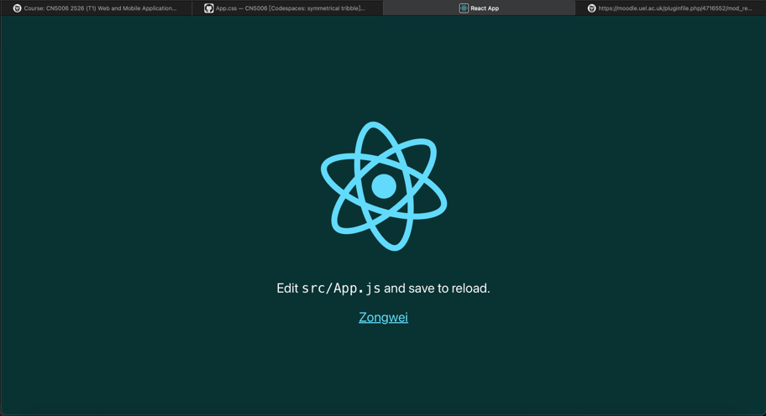
Task2:
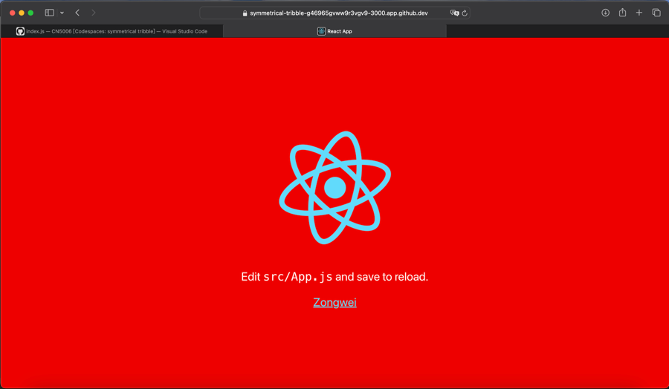
Task3:
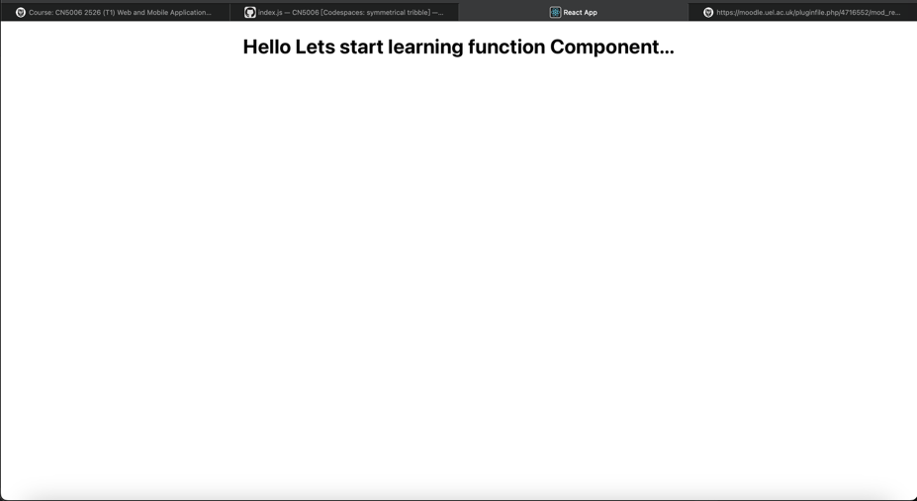

Task4:
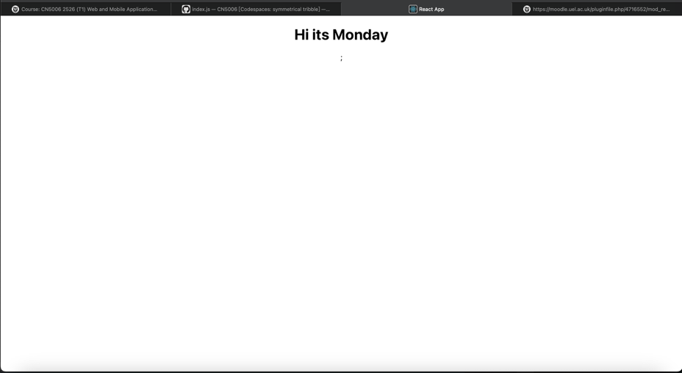
Task5:
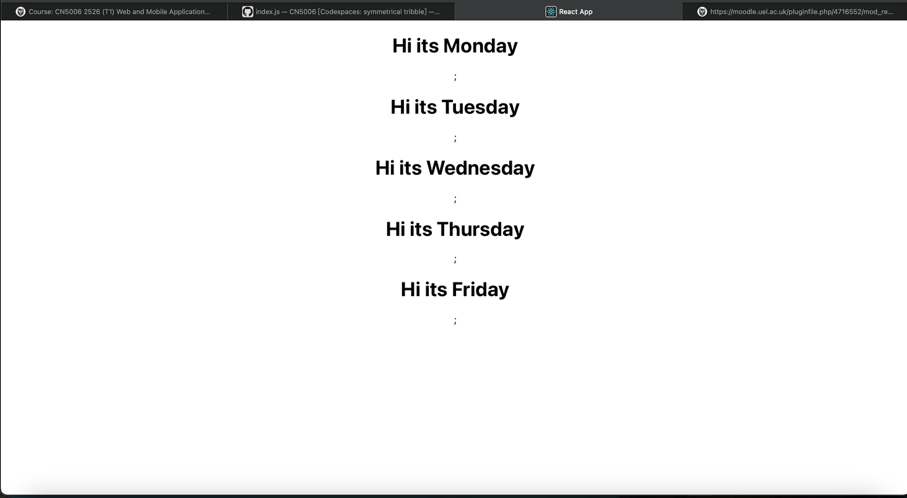
Task6:
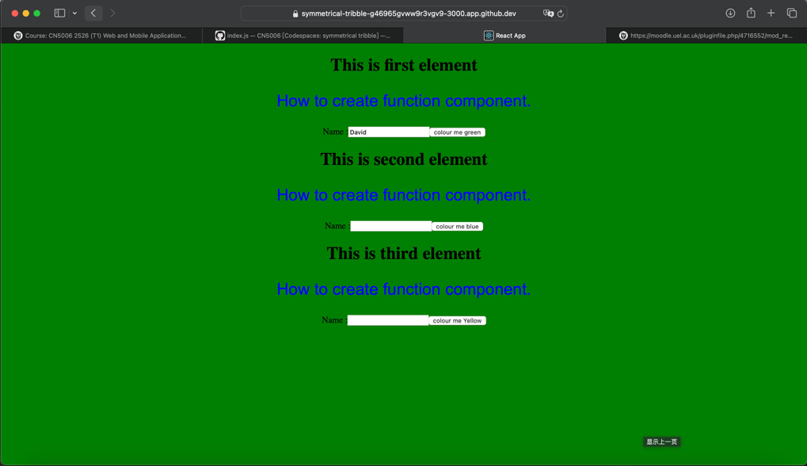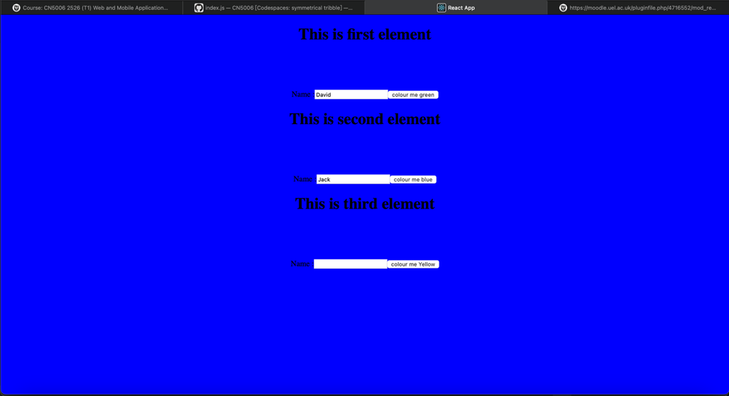
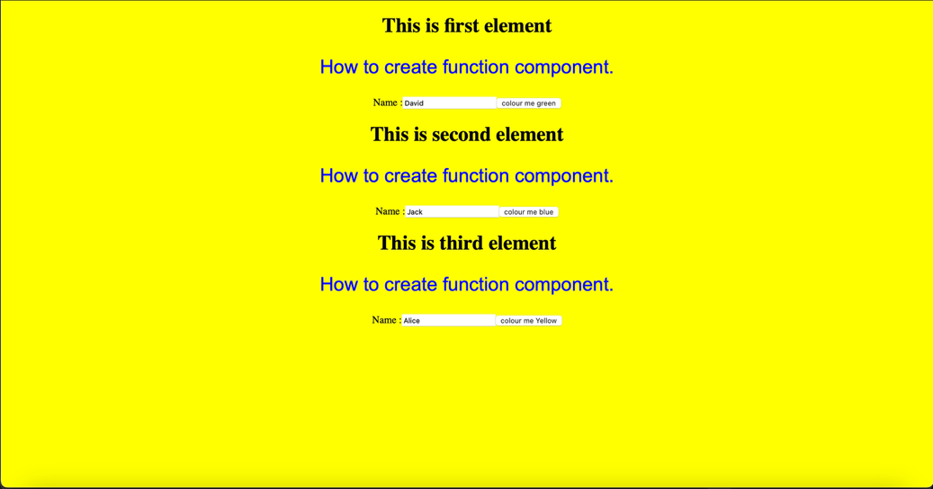

1.What is React
React is an open-source JavaScript library which is used to build fast and dynamic user interfaces for interactive web applications.

2.
React components are created using JavaScript functions.

Without properties
function MyReact() {
return <h1>Hello World</h1>;
}
export default MyReact;

With properties
function MyReact(props) {
return <h1>{props.heading}</h1>;
}
export default MyReact;

3.
ReactDOM.render(
<MyReact />,
document.getElementById('root')
);

4.
ReactDOM.render(
<MyReact heading="this is my first element" />,
document.getElementById('root')
);

5.
<AppColor heading="This is first element" lbl="Name :" color="green" />
- AppColor

- It uses 3 properties:
Heading
lbl
color

6.
function GreetingElementwithProp(props) {
return (
<div className="App">
<h1>Welcome, {props.studentname}</h1>;
</div>
);
}
export default ?????? : export default GreetingElementwithProp;

7. Create AddTwoNumbers.js
import './App.css';

function AddTwoNumbers(props) {

function calculateSum() {
const sum = Number(props.num1) + Number(props.num2);
alert("The sum is: " + sum);
}

return (
<div className="App">
<h2>Add Numbers Component</h2>
<p>Number 1: {props.num1}</p>
<p>Number 2: {props.num2}</p>
<button onClick={calculateSum}>Add Numbers</button>
</div>
);
}

export default AddTwoNumbers;
In index.js:
import AddTwoNumbers from './AddTwoNumbers';

ReactDOM.render(
<React.StrictMode>
<AddTwoNumbers num1="10" num2="20" />
</React.StrictMode>,
document.getElementById('root')
);

